DRAFT v.1.2
March 3, 2024

Hunt Club Community Association
Affordable Housing Committee

_________________________

Riverwood Park:
Proposed Pathway

_________________________________

Board Meeting
March 4, 2024

Introduction

- The HCCA’s Affordable Housing Committee has prepared a discussion paper on the proposed multi-use pathway through Riverwood Park (circulated separately).

- We are requesting the Board’s approval to share this discussion paper with City staff and the developer in order to draw their attention to some key issues.

- There is some urgency to this request. The initial design of the proposed pathway is likely to be approved by City staff in the near future.

St. Mary’s – Landscape Plan

- The Taggart Corporation proposes to build some 600 new homes at the corner of Riverside Drive and Hunt Club Road. This proposal includes a Multi-Use Pathway (MUP) through Riverwood Park.

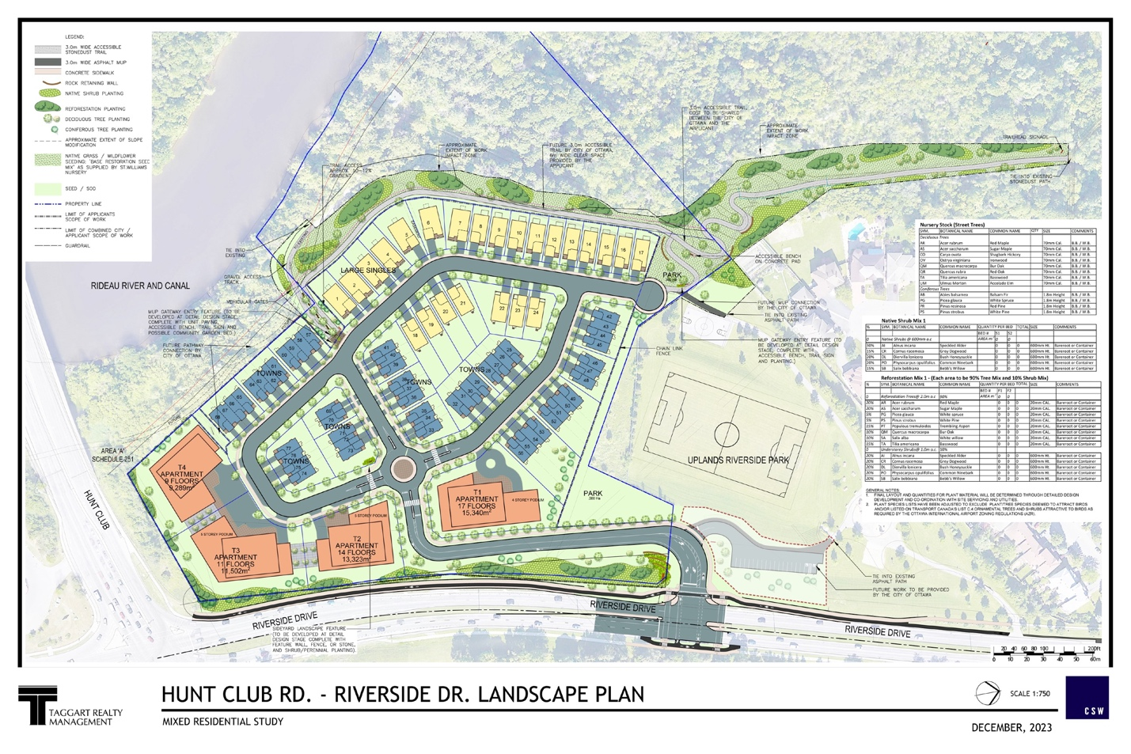
Timelines

- In March 2023, the HCCA provided initial comments and questions to the City of Ottawa and the developer. Our focus was on:

  - The potential for affordable housing
  - The need for improved transportation infrastructure
  - Access to retail services
  - Active transportation (including the MUP)

- In September 2023, the developer responded to these questions. In particular, Taggart provided examples of recent projects which include affordable housing units.

- In December 2023, the developer submitted a revised Environmental Impact Study (EIS) and other supporting documents. This study provided valuable information, but raised some key questions about the route of the pathway.

Site Visit - Field Naturalists

- In February 2024, the HCCA hosted a site visit with experts from the Ottawa Field Naturalists’ Club to examine the proposed route of the pathway.

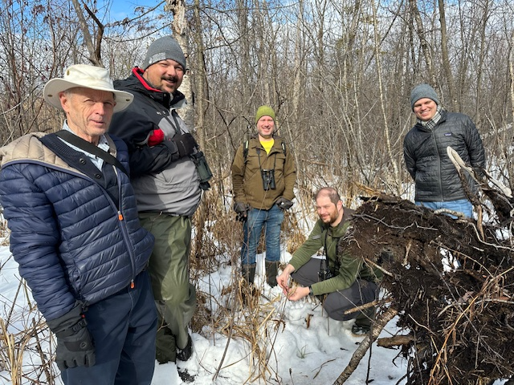
Priority Trees – At Risk

- The site visit found several “priority trees” which are in danger of removal (see red circles below). 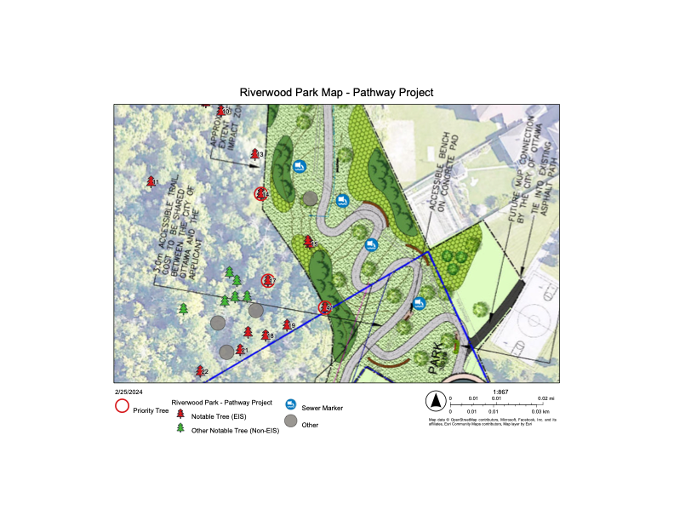
Butternut

- Butternut trees are “endangered” under both provincial and federal legislation. They are in “imminent danger of extinction”.

- The developer’s Environmental Impact Study found two Butternuts. One of them (left) is very healthy, but the EIS recommends removing both of them.

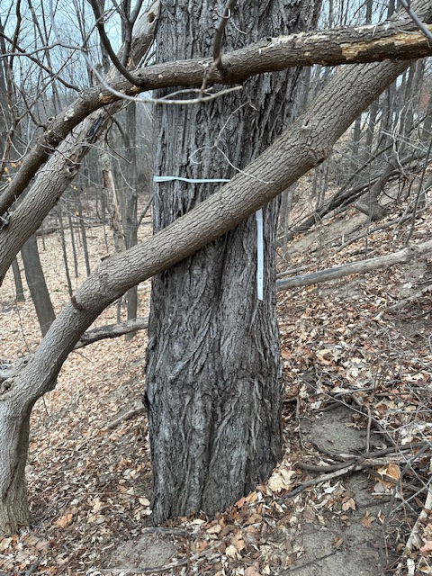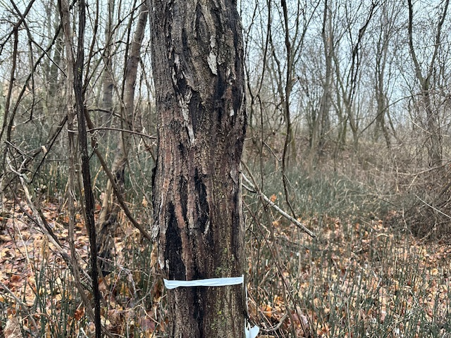
Yellow Birch

- There is a Yellow Birch which is over 250 years old. It’s so old that it was mistaken for a “Black Cherry”. Several other old-growth birches are at risk.

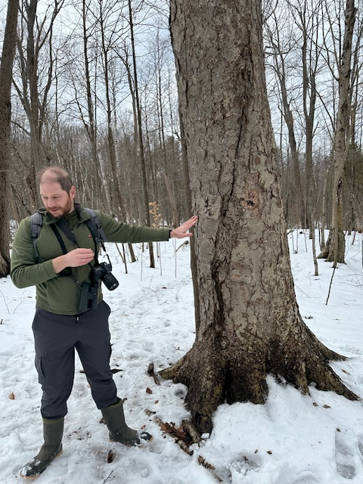
Peachleaf Willow

- At the edge of the “work impact zone”, there is a Peachleaf Willow which is about 70’ tall. It is a contender for the “champion” tree of its kind in Canada.

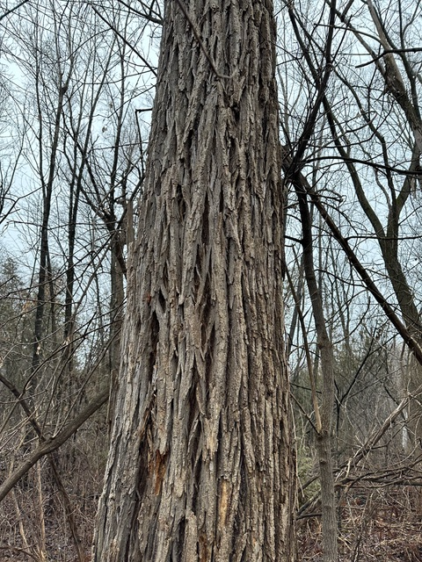
Nature Walk – May 2024

- As a follow-up to the site visit, the OFNC has agreed to co-host a “Nature Walk” in Riverwood Park in May. Councillor Brockington has offered his help to promote this walk.

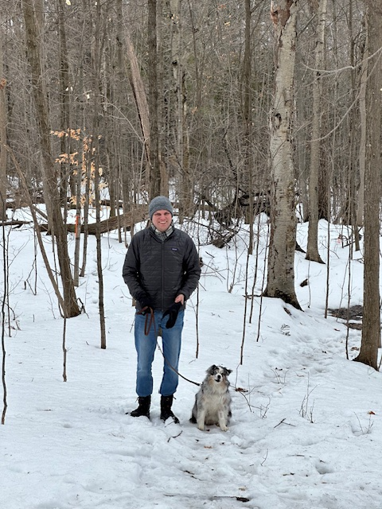
Decision Required

- There is support among HCCA members for a multi-use pathway through Riverwood Park, provided that best efforts are made to mitigate the adverse impacts on the park.

- Where possible, the route of the pathway and the width of the “work impact zone” should be adjusted to protect the healthy Butternuts, the old-growth Yellow Birches, and the “champion” Peachleaf Willow.

- To this end, the Affordable Housing Committee seeks approval to:

  - share the discussion paper with City staff and the developer in order to draw their attention to our findings;

  - advocate for the protection of “priority trees” at risk of removal, such as the endangered Butternut trees;

  - seek further information from City staff about the stewardship of Riverwood Park and report back as required.

